Activity 1.2: Finding the way to the exit
- Write a computer program to move the robot from the entrance to the exit.
You can use the following instructions in your program:
- fd X to move X square(s) forward
- bk X to move X square(s) backward
- rt X to move X degrees right
- lt X to move X degrees left
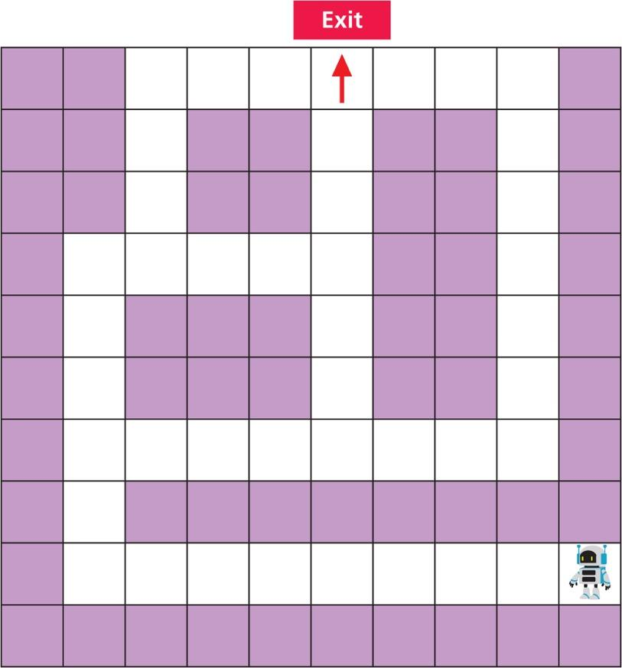

- Swap your computer program with a partner. Can your partner follow your instructions to get the robot out of the room? Are your partner's instructions the same as yours?

